Name:________________________________________ Date:________________ Class Period:_______
Discovering Foods Chapter
Pages 108-115

Kitchen Equipment I.D.

Directions: Match each equipment name below with the correct sketch of the equipment. Write the letter of the equipment name in the blank to the left of each picture. Do not use any name more than once. Some names will not be used.

A. Chef’s knife B. Colander C. Cutting Board
D. Dry Measuring Cups E. Grater F. Kitchen Shears
G. Ladle H. Liquid Measuring Cups I. Pastry Blender
J. Peeler K. Rolling Pin L. Rotary Beater
M. Rubber Scraper N. Serrated Knife O. Turner
P. Spatula Q. Tongs R. Wire Cooling Rack

____1. | 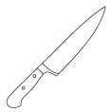 | ____2. | 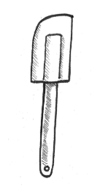 | ____3. | 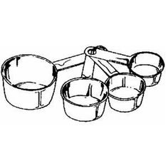 | ____4. | 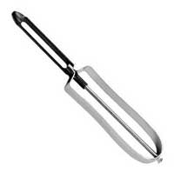
____5. | 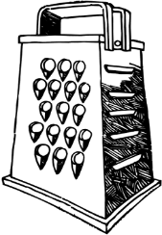 | ____6. | 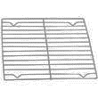 | ____7. | 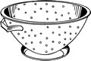 | ____8. | 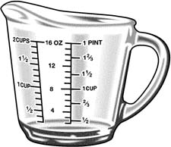
____9. | 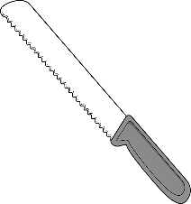 | ____10. | 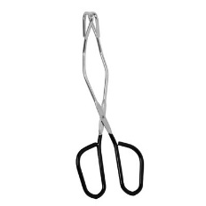 | ____11. | 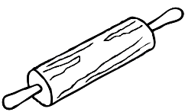 | ____12. | 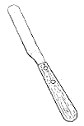
____13. | 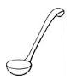 | ____14. | 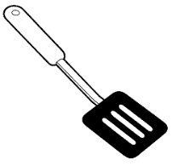 | ____15. | 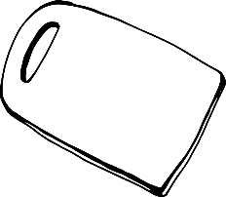 | ____16. | 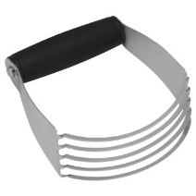
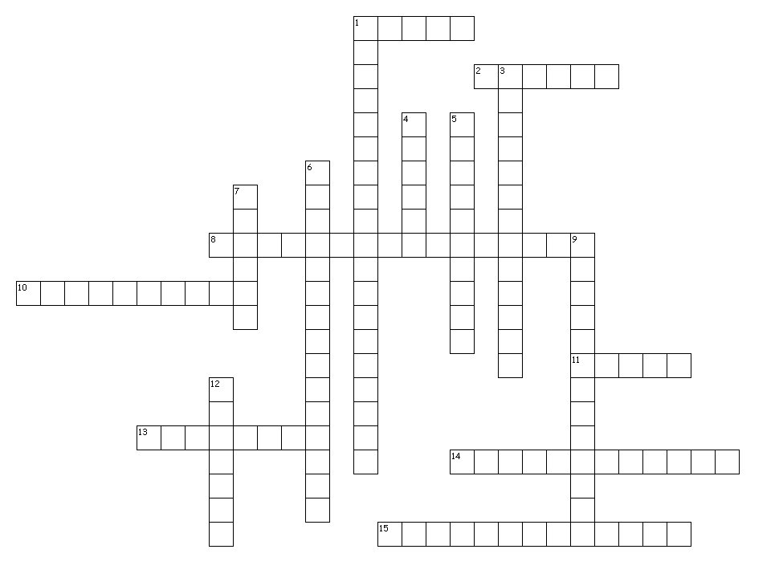
Across

1. used to dip liquids such as soup, from pan to bowl or cup
2. grates food into tiny pieces
8. used to measure dry and solid ingredients
10. for quick slicing, dicing and chopping foods
11. lift and turn food without piercing it
13. drains liquid from foods like pasta
14. protects countertop or table while cutting
15. cuts shortening into flour when making pastry and biscuits

Down

1. made of glass or plastic designed for measuring liquids
3. removes food from spoon, sides of cans, bowls, pans and jars
4. removes the skin from fruits or vegetables
5. rolls out dough for pie crust, biscuits or cookies
6. hold hot foods such as cakes, breads and cookies while cooling
7. lifts and turns foods such as pancakes and hamburgers
9. has a saw-tooth edge for cutting breads and cakes
12. level off dry or solid ingredients when measuring

