Name:___________________________________ Hour:___________________

Choose the machine part that matches each part function. Write the letter of the part in the space provided.
A. Power Socket
B. Throat Plate
C. Bobbin
D. Foot Feed
E. Tension Control
F. Bobbin Case
G. Presser Foot Lifter
H. Thread Guides
I. Hand Wheel
J. Stitch Width Control
K. Feed Dogs
L. Presser Foot
M. Stitch Length Control
N. Spool Pin
O. Reverse
P. Bobbin Winding Spindle

_____ 1. This allows the machine to reverse stitch.

_____ 2. Generally found on the top of the machine, this holds the thread.

_____ 3. When adjusted, this will determine how big or little the stitch is.

_____ 4. The speed of the machine is determined by how hard you step on this.

_____ 5. When lowered, this holds the fabric firmly against the feed dogs.

_____ 6. To fill the bobbin, you will need to use this.

_____ 7. This part surrounds the feed dogs and has guidelines for stitching.

_____ 8. When moved, this part will raise and lower the needle.

_____ 9. When using a zigzag, this will change the size of the pattern.

_____ 10. This will raise and lower the presser foot.

_____ 11. These hold the upper thread in places while stitching.

_____ 12. Adjusting this control will change the tightness of the thread.

_____ 13. These move the fabric through the machine.

_____ 14. This small, flat spool is filled and used as the bottom thread.

_____ 15. When connecting the cord to this, always connect the machine end first.

_____ 16. Found under the needle, this space holds the spool of bottom thread.

Identify the names of the marked machine parts below. Write the corresponding letter for each part in the box provided.
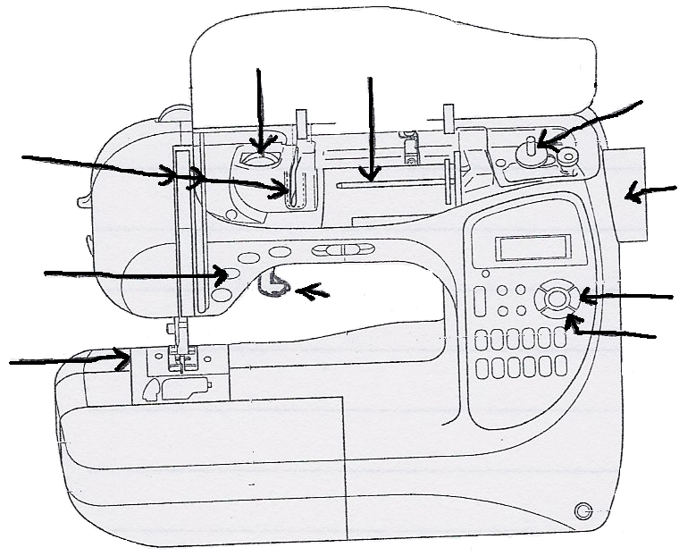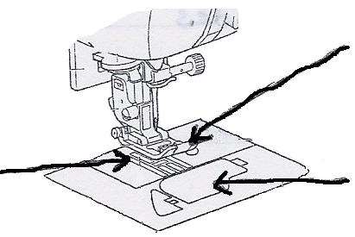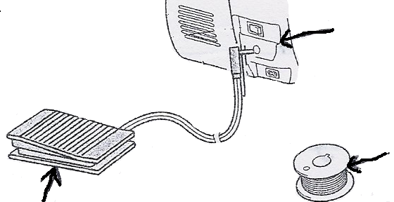
A. Power Socket
B. Throat Plate
C. Bobbin
D. Foot Pedal
E. Tension Control
F. Bobbin Case
G. Presser Foot Lifter
H. Thread Guides
I. Hand Wheel
J. Stitch Width Control
K. Feed Dogs
L. Presser Foot
M. Stitch Length Control
N. Spool Pin
O. Reverse
P. Bobbin Winding Spindle

