GENERAL INSTRUCTIONS
1. Shaded areas in the illustrations indicate the right side of the fabric. Each fabric is shaded differently as shown.
2. All pinning is done with right sides together.
3. Pin all seams before stitching, and remove pins as you are stitching so you don’t hit a pin with the needle.
4. Use ½ inch seam allowances. Sew as accurately as possible.
LAYOUT AND CUTTING INSTRUCTIONS
1. Collect one LARGE square template.
2. Label your fabrics below. Using the provided template, color in the squares to match your intended finished design.
Color 1: _____________________________
Color 2: _____________________________
Color 3: _____________________________
3. Lay Color 1 fabric flat and place Color 2 on top, matching edges. Pin thoroughly around the perimeter
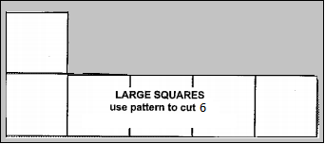
4. Using the 11x11 template to cut 6 squares of the solid colors.

5. Fold Color 3 in half, lay fabric flat and use the 11x11 template and chalk to trace 6 squares

6. ASK FOR MS. LEITHEISER TO CHECK BEFORE YOU CUT!
7. Cut out all squares. Perimeter first, then rows. Move pins to the middles of each square set.

FORMING ROWS –BACKSTITCHING BEGINNING AND END EVERY TIME!!!!!!!!!!!!!!!

1. Arrange the 12 solid squares and 12 patterned squares as in the diagram (colored page) to be sure the sections have been sewn correctly.
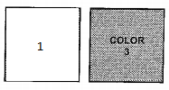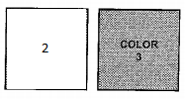
2. Form the sections as follows

-pin a patterned square to a solid square
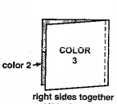
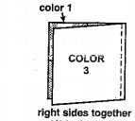
-right sides together
-use 5-7 pins
-edges even

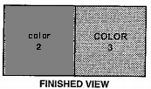
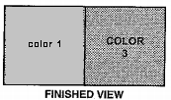
-Stitch the right edge – BACKSTITCH! – the section should look exactly like the ‘Finished View’

-Repeat for the remaining LARGE SQUARES
-You will have 12 sections, arrange according to your colored guide

3. Form the ROWS as follows

-pin a pieced square to a Color 3 square
-right sides together
-use 5-7 pins
-edges even
-stitch with ½ inch seam allowance –BACKSTITCH!
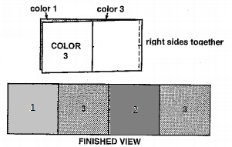
-Repeat with all sections, you will have 6 rows.

FORMING THE BLANKET

1. Arrange the rows as in the colored diagram to ensure that all the sections have been sewn correctly. Notice that each pieced square will be sewn to a COLOR 3 square.
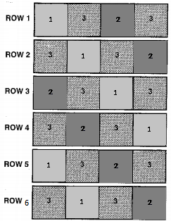

2. Starting from the top, pin the long lower edge of ROW 1 to the upper edge of ROW 2 so that the square seams match and edges are even. Use 11- 15 pins.

3. Stitch ½ inch from the long pinned edge. BACKSTITCH!!!!! At the beginning and end of the stitching line.

The section will look exactly like the finished view.
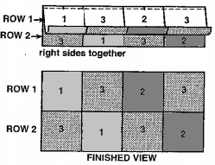

4. Pin a stitch the long lower edge of ROW 2 to the upper edge of ROW 3, matching the seams and edges in the same manner as before. Use 11-15 pins. ½ inch seam allowance and BACKSTITCH. Repeat this process for all the remaining rows.

5. TRIM AS LITTLE AS POSSIBLE!!!!!! Once trimmed, stitch around the perimeter with ½ inch seam allowance, pivoting at the corners.

RAGGING

1. To finish the edges of the quilt, use a small scissors to clip along all seam allowances as follows

- Start on one row of the blanket and work across
- Clip approximately ¼ inch apart
- DO NOT CLIP THROUGH THE STITCHING LINE!!!!

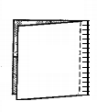
use small scissors to make clips along seam allowances – do not cut through stitches
HANDING IN PROJECT

1. Trim all loose threads!
2. Fold you blanket neatly.
3. Complete the student side of the evaluations
4. Tape your evaluation to your blanket with the masking tape from your tray.
5. Empty your tote tray of all materials.
6. Place your folded blanket on Ms. Leitheiser’s desk chair.

