GENERAL INSTRUCTIONS
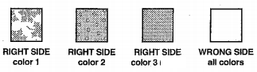
1. Shaded areas in the illustrations indicate the right side of the fabric. Each fabric is shaded differently as shown.

2. All pinning is done with right sides together.
3. Pin all seams before stitching, and remove pins as you are stitching so you don’t hit a pin with the needle.
4. Use ½ inch seam allowances. Sew as accurately as possible.
LAYOUT AND CUTTING INSTRUCTIONS
1. Collect one SMALL and one LARGE square template.
2. Label your fabrics below.
Color 1: _____________________________
Color 2: _____________________________
Color 3: _____________________________
3. Lay Color 1 fabric flat and place Color 2 on top, matching 2 edges. Pin thoroughly around the perimeter
4. Using the SMALL template and the layout picture, use chalk to trace 20 squares.
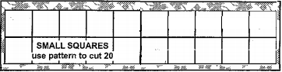
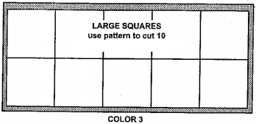
5. Lay Color 3 fabric flat and use the LARGE template, chalk, and template to trace 10 squares

6. ASK FOR MS. LEITHEISER TO CHECK BEFORE YOU CUT!
7. Cut out all squares. Perimeter first, then rows. Move pins to the middles of each square set.
FORMING SQUARES
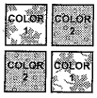
1. Arrange all 40 SMALL squares into piles ensuring that all pieces are RIGHT side up.
2. Assemble the SMALL squares as follows:
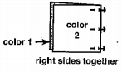
-pin a SMALL square Color 2 to a SMALL square Color 1
-use 3-5 pins
- Right sides together
-edges even

-chain stitch ½ inch from the right edge – the section should look exactly like the ‘Finished View’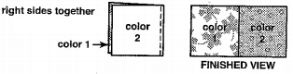
- repeat for all the remaining SMALL squares – you will have 20 sewn sections.
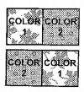
3. Arrange the 20 sections as in the diagram to ensure that all sections will be sewing correctly.

4. Form the large squares as follows.
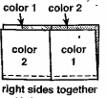
-pin the long lower edge of a section to the long upper edge of another section
-use 5-7 pins
-right sides together
-edges even
-matching previously sewn seams
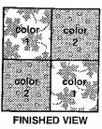
-chain stitch ½ inch from the edge – the section should look exactly like the ‘Finished View’

-you will have 10 - pieced LARGE squares.

FORMING ROWS – BEGIN BACKSTITCHING EVERY TIME

1. Arrange the 10 pieced LARGE squares and 10 COLOR 3 LARGE squares as in the diagram to be sure the sections have been sewn correctly.
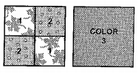

2. Form the sections as follows
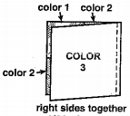
-pin the COLOR 3 LARGE square to a pieced square
-right sides together
-use 5-7 pins
-edges even

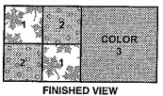
-Stitch the right edge – BACKSTITCH! – the section should look exactly like the ‘Finished View’

-Repeat for the remaining LARGE SQUARES

-You will have 10 sections, arrange them as follows
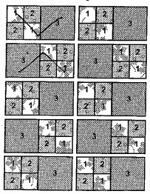

3. Form the ROWS as follows

-pin a pieced square to a Color 3 square
-right sides together
-use 5-7 pins
-edges even
-stitch with ½ inch seam allowance –BACKSTITCH!
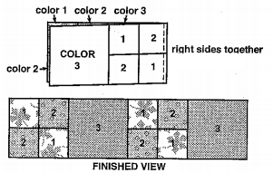
-Repeat with all sections, you will have 5 rows.

FORMING THE BLANKET

1. Arrange the rows as in the diagram to ensure that all the sections have been sewn correctly. Notice that each pieced square will be sewn to a COLOR 3 square.
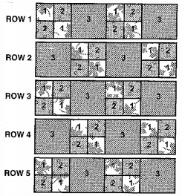

2. Starting from the top, pin the long lower edge of ROW 1 to the upper edge of ROW 2 so that the square seams match and edges are even. Use 11- 15 pins.

3. Stitch ½ inch from the long pinned edge. BACKSTITCH!!!!! At the beginning and end of the stitching line.

The section will look exactly like the finished view.
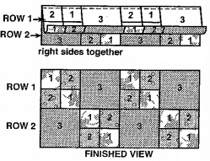

4. Pin a stitch the long lower edge of ROW 2 to the upper edge of ROW 3, matching the seams and edges in the same manner as before. Use 11-15 pins. ½ inch seam allowance and BACKSTITCH. The section will look exactly like the ‘Finished View’
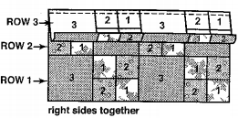

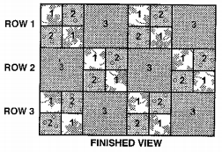

5. Pin and stitch ROW 4 to ROW 3, and then ROW 5 to ROW 4 in the same manner, using a ½ inch seam allowance and BACKSTITCHING each row. The section will look exactly like the ‘Finished View’

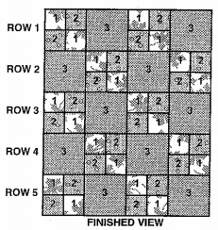

RAGGING

1. To finish the edges of the quilt, use a small scissors to clip along all seam allowances as follows

- Start on one row of the blanket and work across
- Clip approximately ¼ inch apart
- DO NOT CLIP THROUGH THE STITCHING LINE!!!!

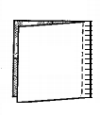
use small scissors to make clips along seam allowances – do not cut through stitches
HANDING IN PROJECT

1. Trim all loose threads!
2. Fold you blanket neatly.
3. Complete the student side of the evaluations
4. Tape your evaluation to your blanket with the masking tape from your tray.
5. Empty your tote tray of all materials.
6. Place your folded blanket on Ms. Leitheiser’s desk chair.

