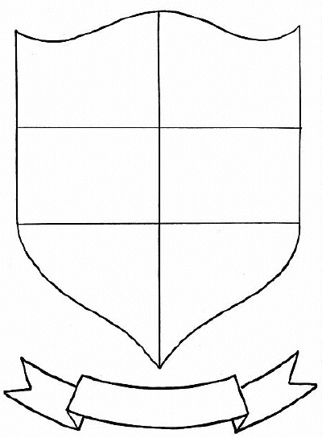
Directions: On this worksheet, your must fill in your coat of arms with six things that describe who you are and what you represent. It can be personal interests, sports, achievements, family background, goals, significant people, etc. At the bottom of the box, explain what it symbolizes. Place your name in the ribbon on the bottom. Cut out both and glue to construction paper before handing in.

