6th Grade Name:________________
Equipment Hunt Hour:________________
Today’s Teen Cp. 33

Fill in the missing piece of sewing equipment on each of the questions below.

Station 1 – page 367

1._________________ are used for cutting out the fabric, long blades with bent or straight handles

2. A ________________________ has a hook-like point, handy for removing stitches.

3. _______________________ are used to clip threads and trim extra fabric from seams.

Station 2 – page 368

4. ___________________ or yard stick is useful for measuring on a flat surface.

5. A __________________________ is a small ruler that has a slide marker that can be set to measure small lengths.

6.___________________________ is a narrow strip or durable plastic often marked with centimeters and inches

Station 3 – page 368

7. _______________________ can include pencils, squares or chalk wheels to mark fabric.

8. A _____________________ and paper can be used to transfer pattern markings to the wrong side of fabric.

Station 4 – page 369

9. An ___________ and a well padded board are necessary for well pressed projects

Station 5 –page 369

10. ______________________ are used to hold the pattern to the fabric and to hold the fabric together during stitching.

11. Use a ______________________ to keep needles and pins handy while you work.

12. ___________________ come in American and European sizes, size range depends on the type of fabric being sewn.

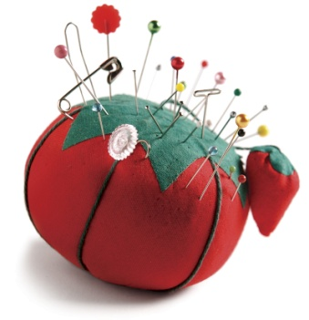
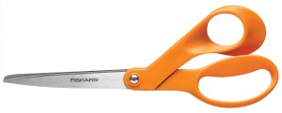
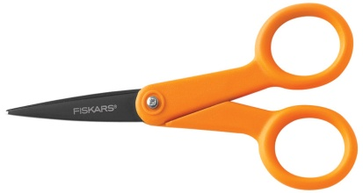
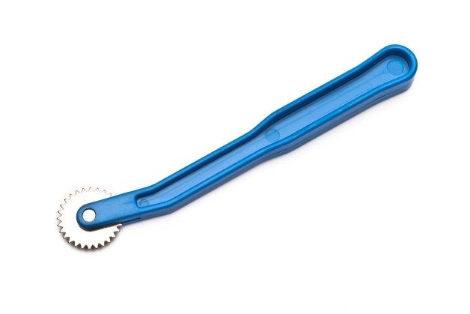
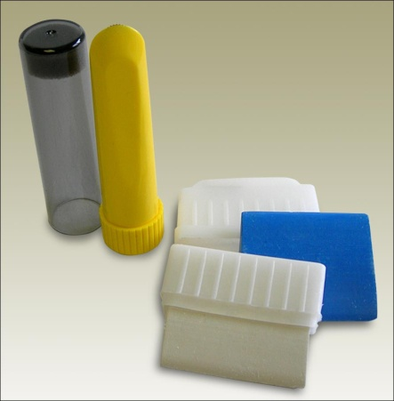
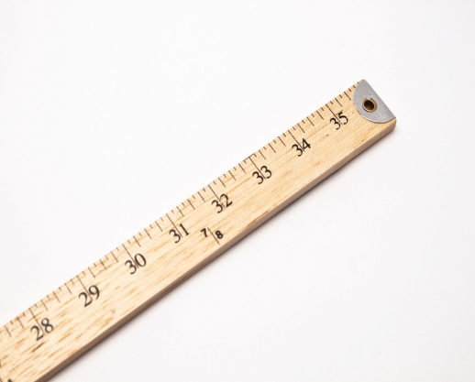
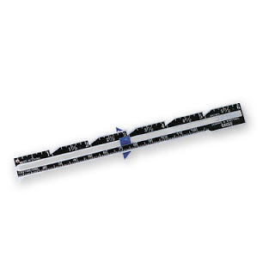
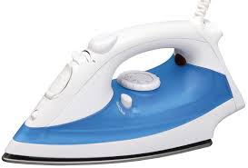
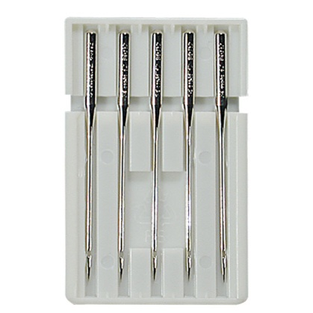
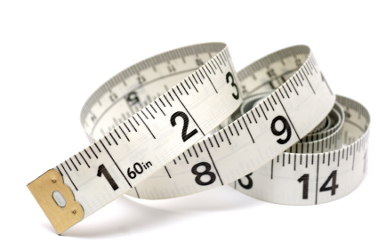
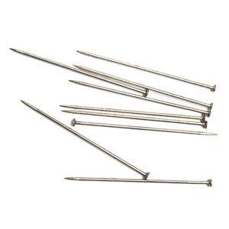
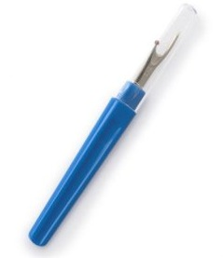
Match each picture to its proper name. Write the name of each piece of equipment next to the correct image.

