7

|  |  |  |
| --- | --- | --- |
| Interactive #6 Page 8-9 | Kitchen Accidents | 6th FACS |

1. Cut along the lines of the activity below and glue it onto page 8 of your notebook.
2. In the picture there are 11 potential kitchen accidents waiting to happen. **CIRCLE** and **NUMBER** each accident.
3. On the lines provided – explain how you would CORRECT each of the different accidents.

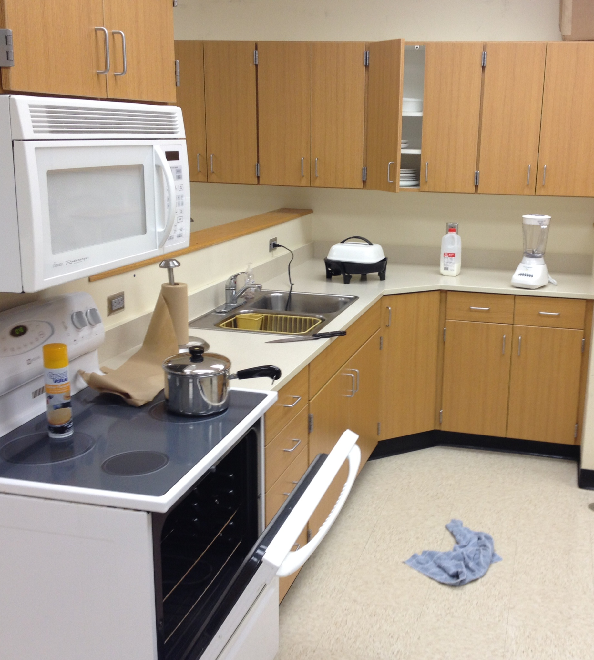

|  |
| --- |
| 1. |
| 2. |
| 3. |
| 4. |
| 5. |
| 6. |
| 7. |
| 8. |
| 9. |
| 10. |
| 11. |