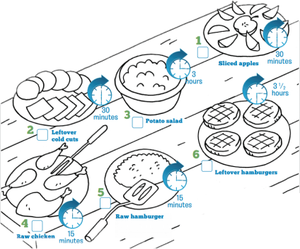

Time + warm temperatures = growth of harmful bacteria on food. Food should not be left out at room temperature for more than two hours. So, foods that sit out for two hours or more should be tossed out. Can you manage your picnic foods so that no one gets sick? For each picture, write letter of the correct answer in the box from these three choices.

A. Cook it Now!

B. Chill Now!

C. Toss It!

|  |  |  |
| --- | --- | --- |
| Interactive # 7 Page 10-11 | Cook, Chill, or Toss | 6th FACS |

1. Cut along the lines of the activity below and glue it onto page 10 of your notebook.
2. Follow the instructions in the activity below.