Name: ______________________________________________ Hour: ____________

Today’s Teen Chapter 33
Page 366-379

Directions: Answer the following questions and statements on the lines provided.

1. What is the advantage of using bent-handled shears?___________________________________
____________________________________________________________________________

2. Why should you avoid using a measuring stick with rough edges?________________________
____________________________________________________________________________
3. What tasks would you use a seam gauge for? Be specific. _______________________________
____________________________________________________________________________

4. List three guidelines for using sewing equipment safely.________________________________
____________________________________________________________________________
___________________________________________________________________________

5. Why is it important to press fabric while you are sewing? ______________________________

___________________________________________________________________________
6. Why are ball-point needles helpful in sewing knit fabric? _______________________________
____________________________________________________________________________

7. What markings can be found on most sewing machine throat plates? ______________________
____________________________________________________________________________

8. What do the feed dogs do? _______________________________________________________
____________________________________________________________________________

9. A sewing machine sews with two threads, one from the top and one from the bottom. What are they called? _________________________________________________________________
10. What is backstitching? _________________________________________________________

11. Why is backstitching done?_____________________________________________________

12. What does the term tension refer to? ______________________________________________

____________________________________________________________________________

13. What is the first step in correcting a tension problem on the sewing machine?
____________________________________________________________________________
____________________________________________________________________________

14. Identify the differences between the right and the wrong sides of fabric. _________________

____________________________________________________________________________

15. Describe the step-by-step process for sewing a pivot turn. _____________________________

__________________________________________________________________________

16. Explain how I could identify a hem and a seam on a sewing project. _____________________

____________________________________________________________________________

____________________________________________________________________________

Directions: Identify each of the sewing tools show below. In the space provided, write their proper names and then provide a brief description of their use. Be specific in your descriptions.

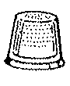
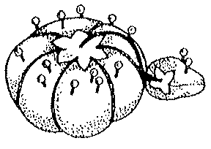
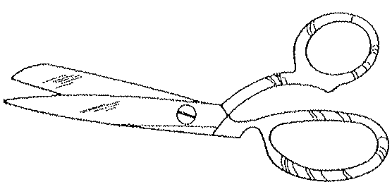
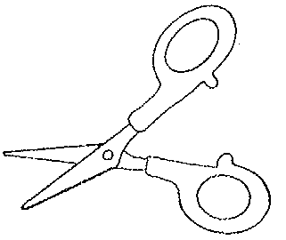
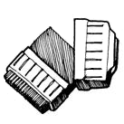
2.
1.

4.
3.

6.
5.

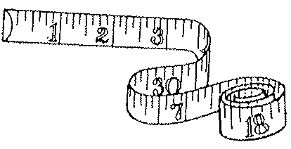
7.

8.

Equipment Name Use

1. ___________________________ __________________________________________

2. ___________________________ __________________________________________

3. ___________________________ __________________________________________

4. ___________________________ __________________________________________

5. ___________________________ __________________________________________

6. ___________________________ __________________________________________

7. ___________________________ __________________________________________

8. ___________________________ __________________________________________

Directions: Find the term from the list below that matches each description and write the number of that term in the small bow in the upper right-hand corner of the square that corresponds with the matching description. No term will be used more than once. If all your answers are correct, the total of the numbers in each row across, down, and diagonal, will always be the same “Magic Number.” Write the Magic Number in the space provided.

TERMS
A
D
B
C
- Hand Wheel
- Thread Take-Up Lever
- Throat Plate
- Bobbin
G
F
E
H
- Bobbin Case
- Bobbin Winder Spindle
- Feed Dogs
- Presser Foot
- Presser Foot Lifter
K
J
I
L
- Tension Control
- Stitch Length Control
- Stitch Width Control
- Stitch Pattern Control
M
P
O
N
- Reverse
- Spool Pin
- Thread Guides

The Magic Number is _____________

DESCRIPTIONS

- Holds the upper thread in place as it moves through the machine  - Feeds thread from the spool to the needle  - Contains seam allowance markings for accurate sewing  - Can be adjusted to make different decorative stitching patterns  - Holds the bobbin and is found beneath the throat plate  - Used to adjust stitches from short to long  - Adjusts the tightness or looseness of the upper thread  - Holds the fabric firmly in place against the feed dogs for sewing | - Raises and lowers the presser foot  - Has a tooth-like surface that moves the fabric during stitching  - Holds the bobbin thread while thread is wound from the spool  - Adjusts the width of stitches when using zigzag or decorative stitches  - A small, flat spool that holds the bottom thread  - Allows you to stitch backward to secure the end of the seam  - Holds the spool of thread  - Controls the up-and-down movement of the needle and the thread take-up lever.

