Making a Mobile: Vitamins & Minerals
Students will select a vitamin or mineral and construct a mobile. To receive 100% the mobile must be turned in on the due date with the following:
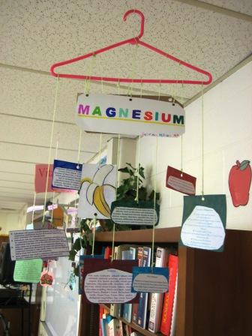
Content - Accuracy
At least 7 accurate facts are displayed on the mobile including:
- Function(s) - why does my body need this?
- Deficiencies (ex: What happens when you don't have enough Calcium?)
  - Disease name and symptoms
- Surpluses (ex: What happens when you consume too much Calcium?)
  - Symptoms
- 4 sources – what foods do I need to get this
Attractiveness: The mobile is exceptionally attractive in terms of design, layout, and neatness (typed). Information is on both sides of each card.
Grammar: There are no grammatical mistakes on the mobile.
Labels: Each section/card on the mobile is clearly labeled with labels that can be read from at least 3 ft. away. Larger font used for title of card or separate card (Ex: SOURCES). There is a title on the Mobile of the Vitamin or Mineral.
Graphics: 4 pictures are included on the mobile. All pictures are in focus and easily viewed and identified from 4ft. away. Student printed off colored images, print and then color images, or used real items (ex: milk carton)

Assemble this information on a coat hanger with string and construction paper/cardstock/tag board.

Our Vitamin or Mineral is __________________________________
This is due: ____________________
We will work in FACS class, on _______________________

Making A Mobile: Vitamins & Minerals
Student Name: ________________________________________ Vitamin/Mineral: __________________

CATEGORY | 3 | 2 | 1 | 0 | TOTAL
Content - Accuracy | At least 7 accurate facts are displayed on the mobile including:  - Function(s)  - Deficiencies (name & symptoms)  - surpluses (symptoms or issues)  - 4 food sources | 5-6 accurate facts are displayed on the mobile. | 3-4 accurate facts are displayed on the mobile. | Less than 3 accurate facts are displayed on the mobile. | 21 points
Attractiveness | - The mobile is exceptionally attractive in terms of design, layout, and neatness (typed).  - Information is on both sides of the card.  - String and glue used in construction.  - Information is mounted on Construction paper | - The mobile is attractive in terms of design, layout and neatness (typed).  - Information is only on one side of the card.  - Staples used in construction  - Not all information is mounted on construction paper | - The mobile is acceptably attractive though it may be a bit messy (not typed).  - Tape used in place of string in construction  - No construction paper used. | The mobile is distractingly messy or very poorly designed. It is not attractive, sloppy, messy and hard to follow. | 12 points
Picture -Clarity | - Four different pictures are all in focus and the content easily viewed and identified from 4ft. away.  - Student printed off colored image or used real items (ex: milk carton)  - Images are same on both sides of card | - Three different pictures are all in focus and the content easily viewed and identified from 4ft. away.  - Colored computer images used but only on one side of card.  - Images are different on each side of card | - Two different pictures are all in focus and the content easily viewed and identified from 4ft. away.  - Pictures are in black/white or drawn by hand. | There are one or less pictures on the mobile | 9 points
Labels & Font | - Title Card is LARGE and TYPED  - Each section (Surplus, Deficiency, Sources & Additional Info) is labeled SEPERATLY and TYPED  - Information can be read from 4 feet | - Title Card is same size as title cards and TYPED  - Each section (Surplus, Deficiency, Sources & Additional Info) is TYPED  - Information can be read from 3 feet | - Title Card is not typed  - Each section (Surplus, Deficiency, Sources & Additional Info) is labeled (not typed) but separate  - Information can be read from 2 feet | - No title card  - Section information not identified  - Information can be read from 2 feet | 9 points
Grammar | There are no grammatical mistakes on the mobile. | There is 1 grammatical mistake on the mobile | There are 2 grammatical mistakes on the mobile. | There are more than 2 grammatical mistakes on the mobile. | 3 points
Grand Total ______/55

