Writing Checks

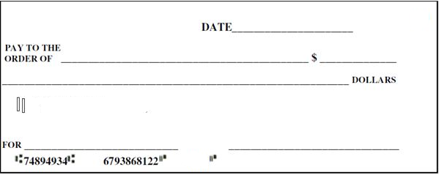
Using your complete register, fill in the correct information on the checks below.
Money Instructor Bank
Anywhere, US
103
103
Money Instructor Bank
Anywhere, US
102
102
Money Instructor Bank
Anywhere, US
101
101

